

CSE370: Database Systems
Project Report
Project Title: KrishiDirect

Group No.: 09, CSE370 Lab Section: 15, Summer 2026
ID | Name | Contribution
24241069 | Fyaz Ahmad Saad | Database Connect, Database Development, Backend Development, Overall Testing
23301647 | Ahmed Naim Rahman | Database Development, Overall Debugging, Frontend Development
24101402 | Nusrat Upama | Database Development, Overall Testing, Frontend Development

Table of Contents

Section  No | Content | Page No
1 | Introduction | 3
2 | Project Features | 4
3 | ER/EER Diagram | 5
4 | Schema Diagram | 6
5 | Normalization | 7
6 | Frontend Development | 8
7 | Backend Development | 11
8 | Source Code Repository | 14
9 | Conclusion | 14
10 | References | 15

Introduction

KrishiDirect is a web-based database system designed to address major problems in the agricultural supply chain of Bangladesh by connecting farmers directly with consumers and commercial buyers. In agricultural regions such as Bogura, Rajshahi, and Natore, marginal farmers often depend on traditional middlemen such as farias and arathdars, which can result in farmers receiving low prices for their crops. At the same time, consumers and commercial buyers in Dhaka often have to pay much higher prices. KrishiDirect aims to reduce this gap by creating a direct and transparent Farmer-to-Consumer (F2C) marketplace.
The platform supports different types of users, including farmers, retail customers, wholesale buyers, storage facility managers, delivery partners, and administrators. Farmers can register their products, set quantities and prices, manage orders, and use available cold storage facilities. Retail and wholesale buyers can search for products based on their requirements, place orders, and choose suitable purchasing quantities. Administrators can manage users, products, orders, storage facilities, and other activities of the system.
At the core of KrishiDirect is a database-driven system that manages important agricultural operations. The system checks cold storage availability before confirming a booking to prevent overbooking. It also provides a dynamic pricing mechanism that calculates a fair price range using recent successful sales from the same district. This helps reduce unfair pricing and protects farmers from being forced to sell their products at extremely low prices. The system can also combine produce from nearby farmers into a single truckload, which helps reduce transportation costs and makes delivery to Dhaka more efficient.
In addition to marketplace and storage management, KrishiDirect supports both retail and wholesale purchasing. Farmers can define a minimum order quantity (MOQ), allowing the system to distinguish between small retail orders and large wholesale orders. Buyers can also pre-order products and cancel orders even after payment according to the system rules. For perishable products, the system monitors storage and shelf-life information and can generate alerts before the products reach their expiration threshold. The system also supports a hub-and-spoke delivery model, where wholesale orders can be transported directly while retail orders can be sent through centralized distribution hubs and local delivery services.
The frontend is built with PHP, HTML, and CSS; the backend uses MySQL. Together, these components form a complete, functional, and deployable system for KrishiDirect. ER/EER diagrams and schema diagrams are designed to build the system.

Project Features

ID,  Name | Features [3 per member]
24241069  Fyaz Ahmad Saad | Ft 1 | Cold Storage Inventory Constraints
24241069  Fyaz Ahmad Saad | Ft 2 | Dynamic Pricing Engine (Anti-Exploitation)
24241069  Fyaz Ahmad Saad | Ft 3 | Multi-Leg Logistics Joining (Bulk Truck-Pooling)
23301647  Ahmed Naim Rahman | Ft 1 | Audio & color buttons for instructions
23301647  Ahmed Naim Rahman | Ft 2 | Direct F2C Order Matching & Escrow Settlement
23301647  Ahmed Naim Rahman | Ft 3 | Dual-Mode Retail & Wholesale Filtering (MOQ Engine)
24101402  Nusrat Upama | Ft 1 | Pre-order and order cancellation after payment:
24101402  Nusrat Upama | Ft 2 | Perishable Shelf-Life & Spoilage Alert System
24101402  Nusrat Upama | Ft 3 | Hub-and-Spoke Last-Mile Delivery Router

ER/EER Diagram

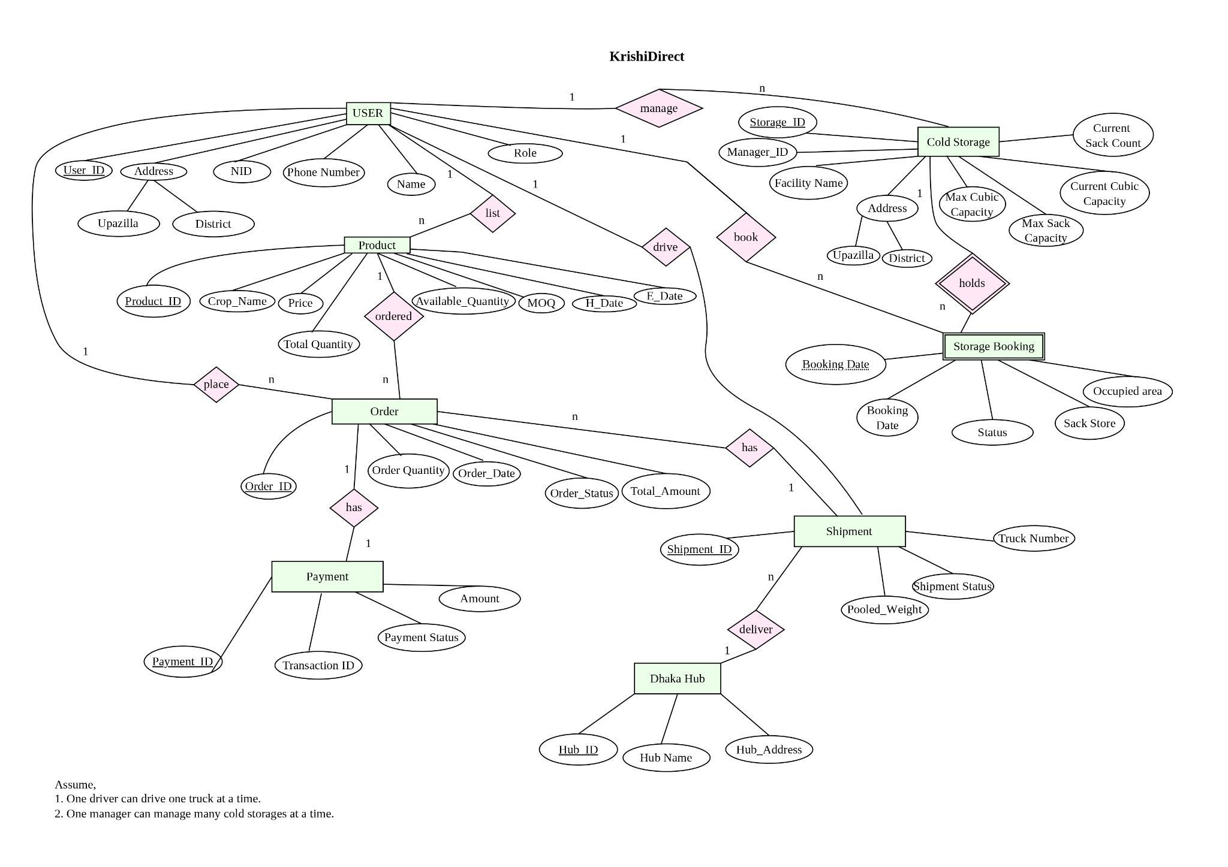

Schema Diagram

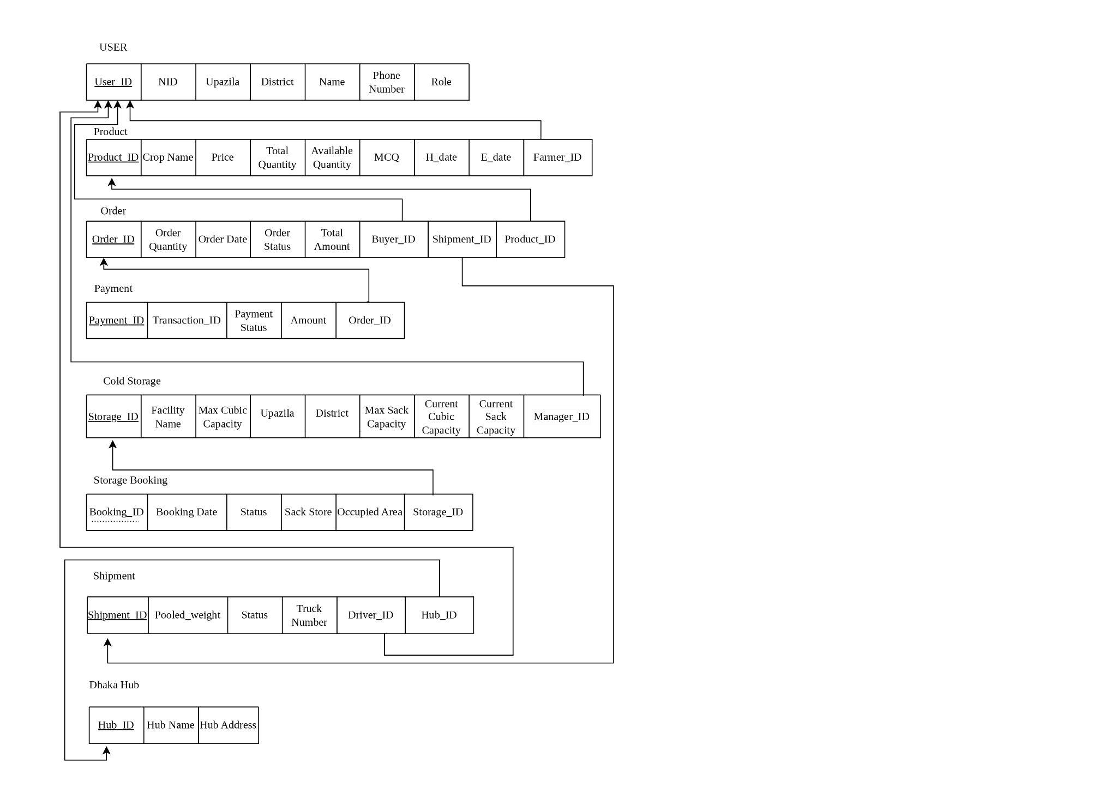

Normalization

- Explain if your converted Schema is in 1NF or not. If not, decompose it to 1NF.
- Explain if your converted Schema is in 2NF or not. If not, decompose it to 2NF. Can there be any partial functional dependencies in your relational schema?
- Explain if your converted Schema is in 3NF or not. If not, decompose it to 3NF. Can there be any transitive dependencies in your relational schema?

Normalization is not needed for this project

Frontend Development

The frontend development was done using HTML and CSS.

Contribution of ID: 24241069, Name: Fyaz Ahmad Saad

Designed the frontend page structure and built the login, register, and logout pages. Designed the farmer dashboard. Added the status of the buyer. Farmers' sold amounts and active cold storage counts. Designed the products page for farmers to browse products.

Contribution of ID: 23301647, Name: Ahmed Naim Rahman

Designed the manager dashboard and cold storage booking page; managers can add cold storage options, a buyer order processing dashboard, a buyer notification system, pre-order, and cart options.

Contribution of ID: 24101402, Name: Nusrat Upama

Shipment management dashboard, truck driver pooling system, and truck driver status are designed.

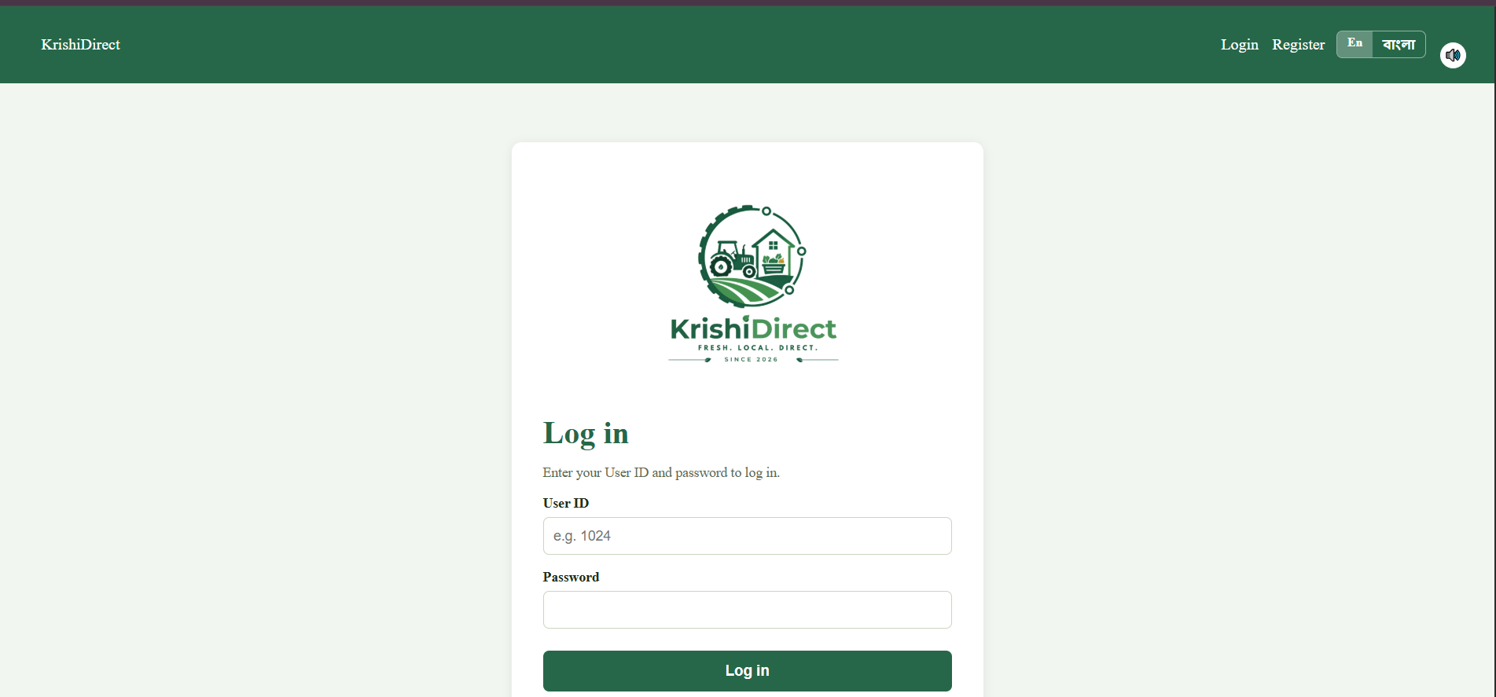

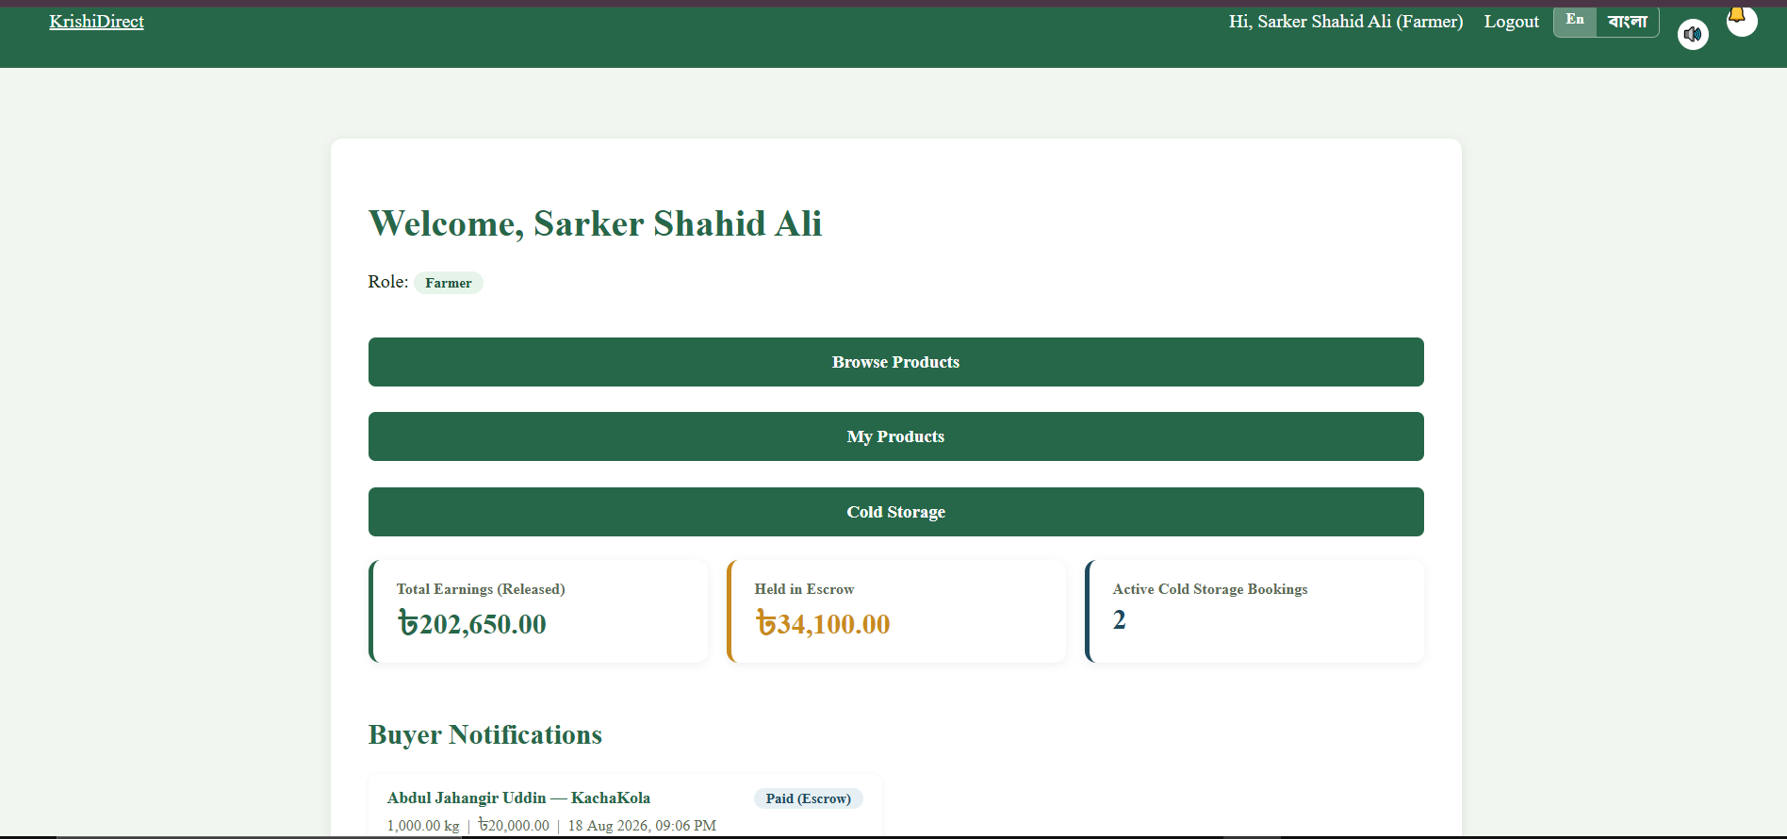

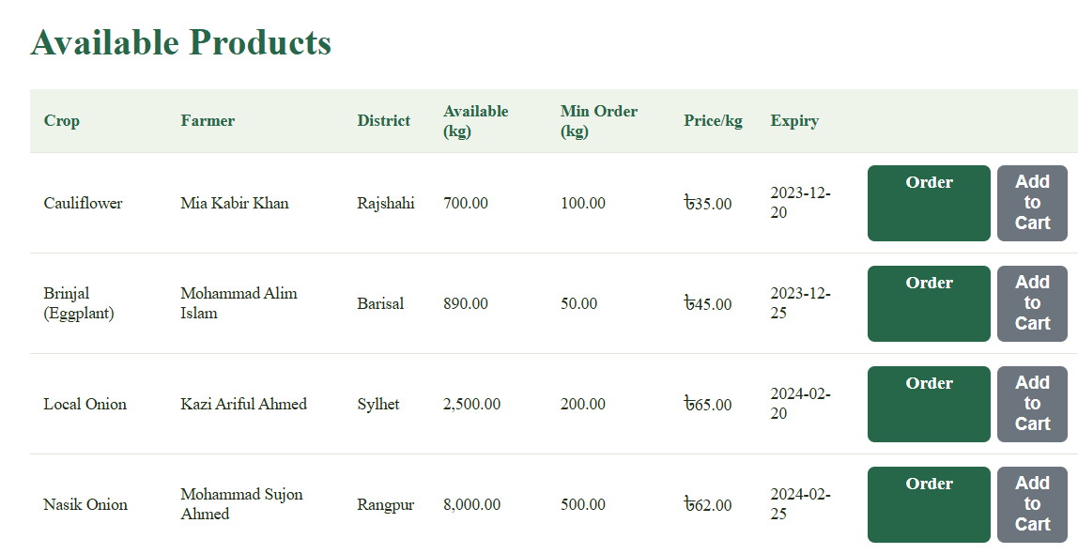

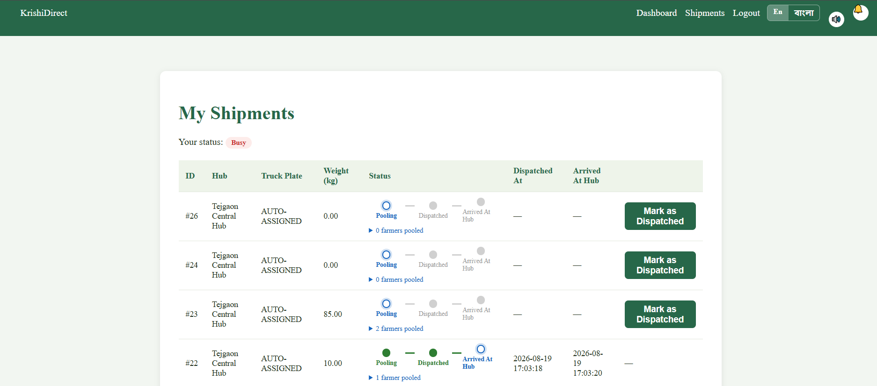
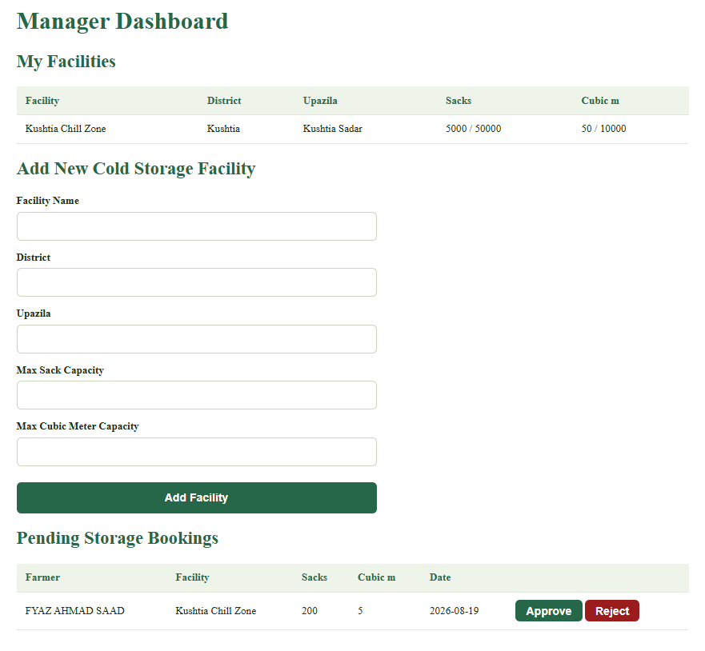
Backend Development

The backend development was done using PHP and MySQL.

Contribution of ID: 24241069, Name: Fyaz Ahmad Saad
Development of the core database connection and backend operations, including cold storage inventory and capacity constraint logic, dynamic product pricing, and logistics-related order processing. Also contributed to database development, backend integration, and overall system testing.
Contribution of ID: 23301647, Name: Ahmed Naim Rahman
Development of backend support for direct farmer-to-consumer order matching and escrow-based payment settlement, including order validation and processing. Implemented backend logic for retail and wholesale purchasing through minimum order quantity (MOQ) validation, and contributed to overall database development and debugging.
Contribution of ID: 24101402, Name: Nusrat Upama
Development of backend logic for pre-orders and order cancellation processes, along with support for order and payment status handling. Contributed to database development, frontend-backend integration, and overall system testing, including features related to perishable product management and delivery operations.

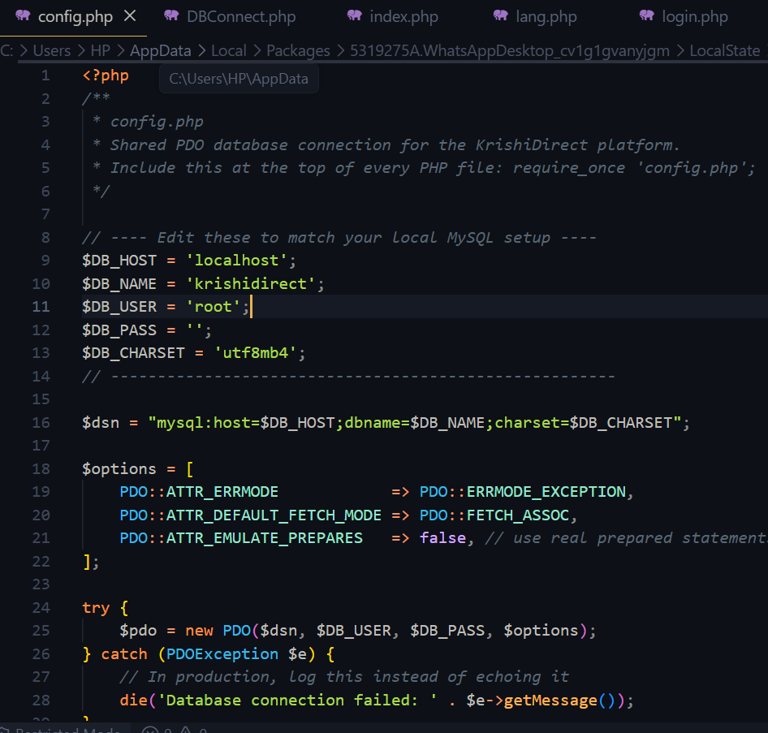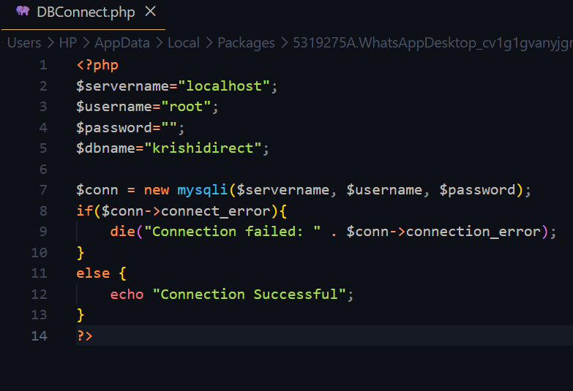
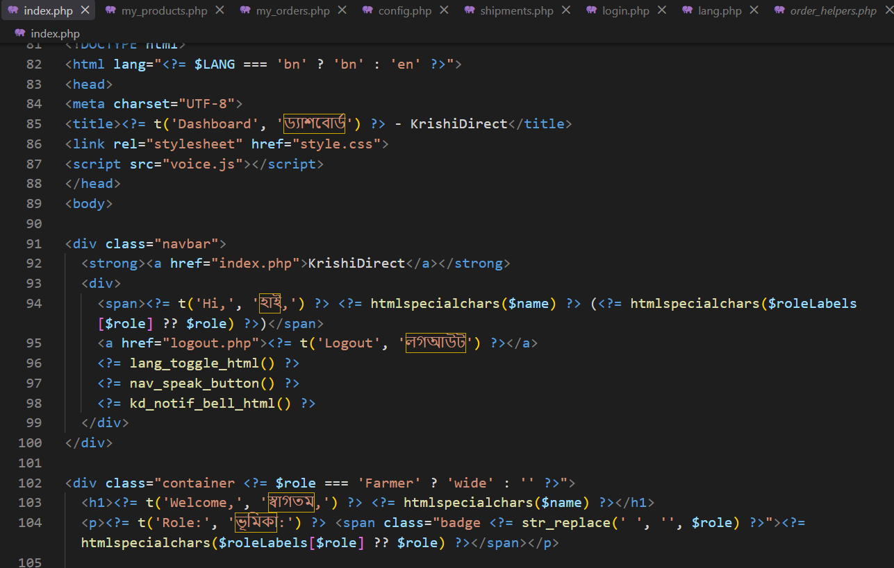
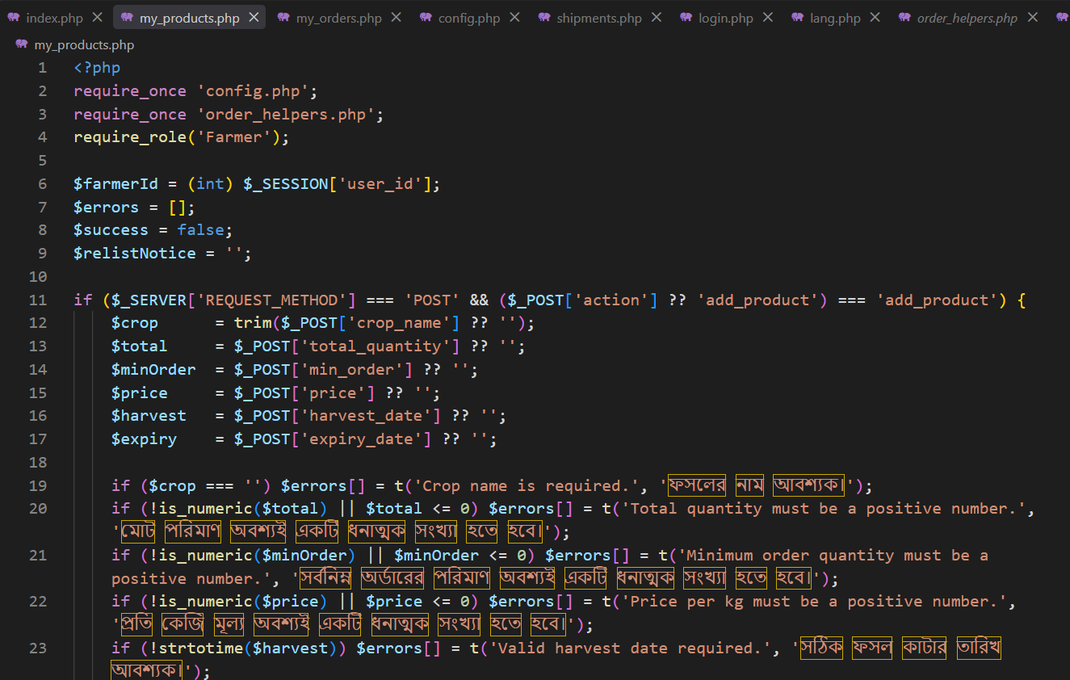
Source Code Repository

Main Folder Link: CSE370 Project
Project Code: Project code

Conclusion

KrishiDirect is a website that helps farmers in Bangladesh sell their crops directly to buyers without using middlemen. This allows farmers to get fair prices based on recent market data while keeping costs low for buyers. The platform also lets nearby farmers share shipping trucks to save money on transport, book cold storage space, and get alerts before produce spoils, making the entire farm-to-market process smoother and more reliable.

References

- Demo Project Part 1 | CSE370 | RBR | Class Recording
- Demo Project Part 2 | CSE370 | RBR | Class Recording

